Name: …………………………………………………………

Class: ……………………………

Year Group: ……………………………



Before you watch the webinar please answer the following questions:

In your own words what do you think Advanced Materials are?

**Answer** - Materials that are used in high-technology applications are basically advanced materials, such as materials that are used for lasers, integrated circuits, magnetic information storage, liquid crystal displays (LCDs), fibre optics, mobile phones , 5G equipment, smart meters etc.



**Answer** - Problem solving, flexibility, team working, ability to work on your own or to play a role for a team approach to work, willingness to learn, enthusiasm, logical thinking etc.

What skills and qualities do you think an employer in the Advanced Materials & Manufacturing s might want their employees to have?

What skills and qualities do you think an employer in the Advanced Materials & Manufacturing sector might want their employees to have?

What everyday things do we use regularly that require the use of advanced materials? **Answer** – Electronics, medical equipment, smart phones, robotics, automotive sat nav, aeroplanes, internet, electric vehicles etc.

Now watch the Webinar - <https://vimeo.com/420647574>

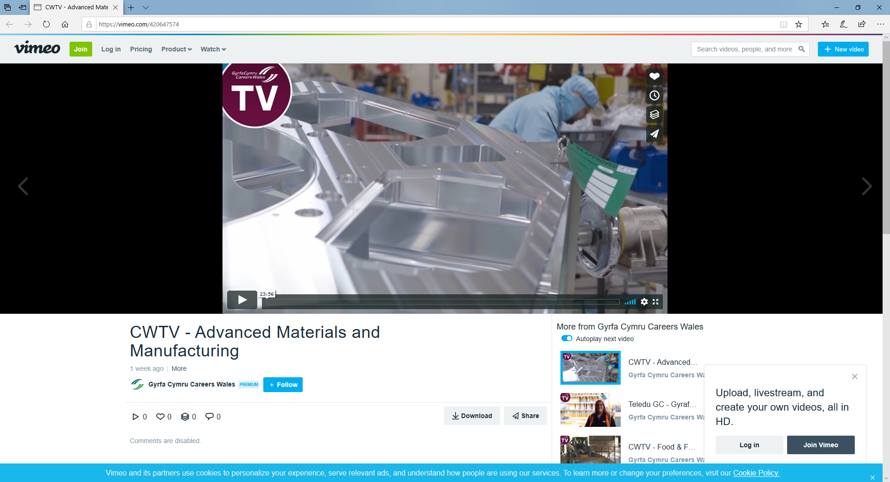

In which sub-areas are important customers for the Advanced Materials & Manufacturing industry?

**Answer** – Automotive, communications, healthcare, aerospace companies, safety and security, internet providers and associated companies, energy companies, robotic manufacturers etc.

1. Which area of Wales has the highest concentration of workers in the Advanced Materials & Manufacturing sector? - **Answer** - (Video 1min 20 sec) Flintshire
2. How many people does that relate to? **Answer** – 13,500 people employed in Flintshire, (6,000 in the aerospace sector in Flintshire)
3. What is the approximate number of people employed in the Advanced Materials & Manufacturing sector in Wales? **Answer** - 80,000

Can you name three companies or organisations who are a part of the Compound Semiconductor sector in South Wales?

1.

2.

3.

Can you name three companies or organisations who are a part of the Compound Semiconductor sector in South Wales?

**Answer** - Cardiff University, Swansea University, CS Hub, Catapult, SPTS, Microsemi, Newport Wafer Fab and IQE.

(The further resources section at the end of this document has links to these companies

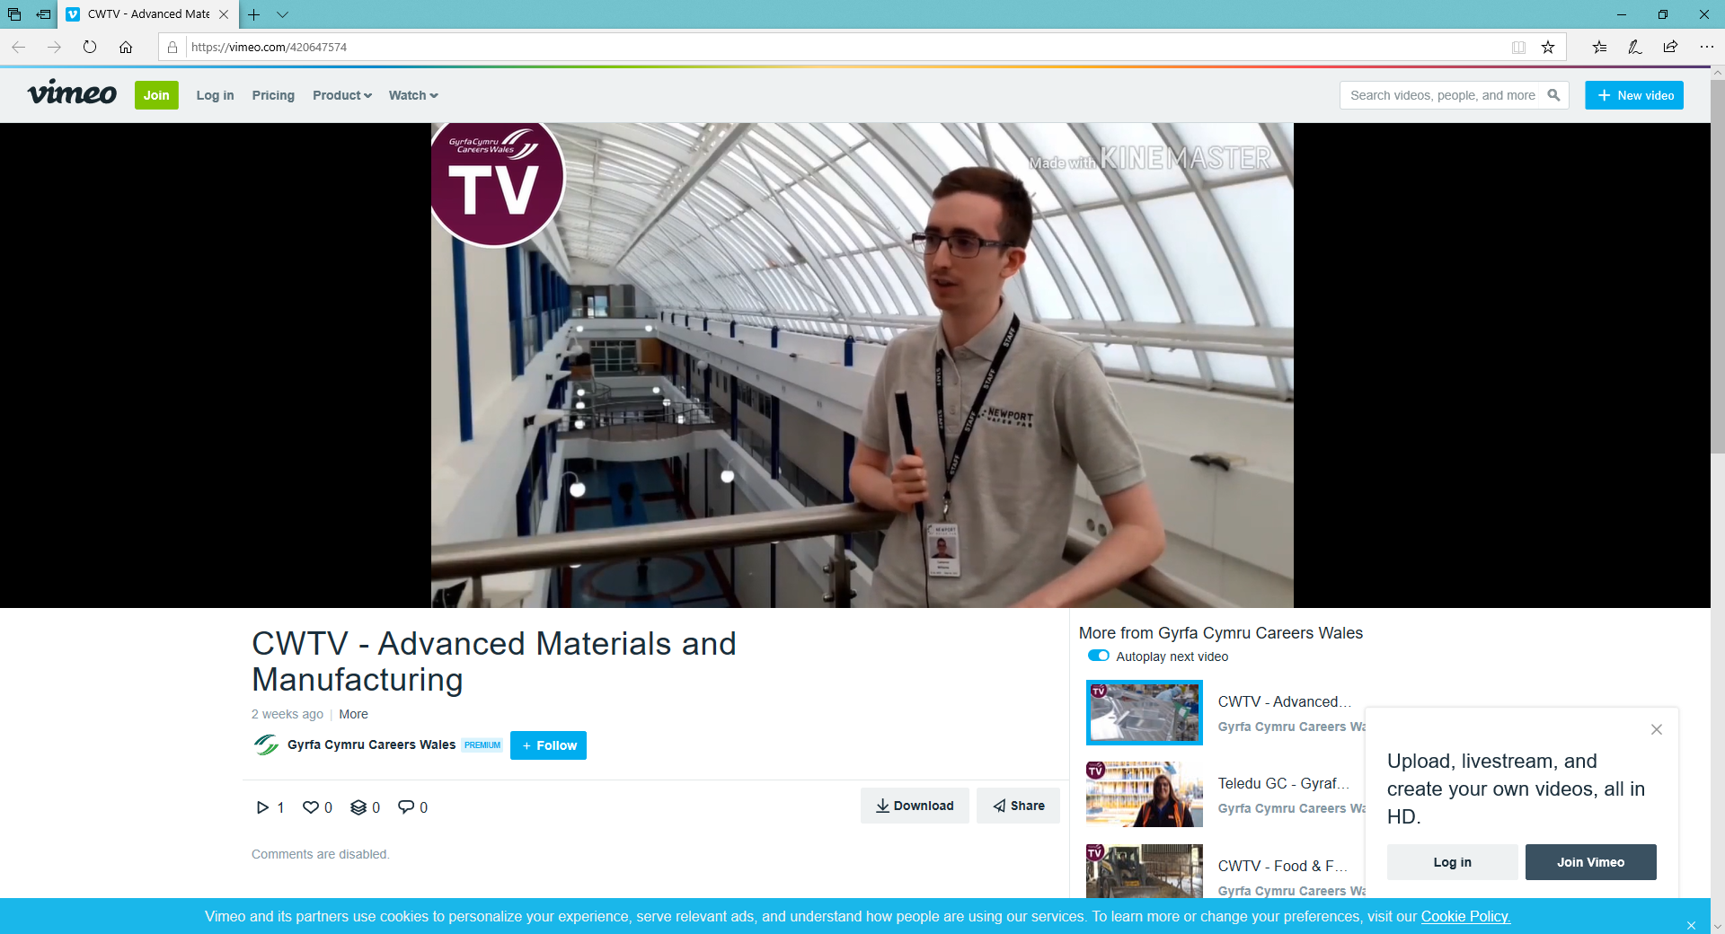

Cameron Williams is an apprentice at Newport Wafer Fab.

1. What qualifications is he working towards? **Answer** – Level 3 BTEC Electronic and Electrical Engineering
2. How many days a week does he spend in:
   1. College – Answer 1Day
   2. Work – Answer 4 days per week

What are your thoughts about Cameron’s work and study programme, why would it suit you **OR** why would it not suit you?

Choose one of the speakers within the webinar and in your own words write a short piece about them

No more than 150 words

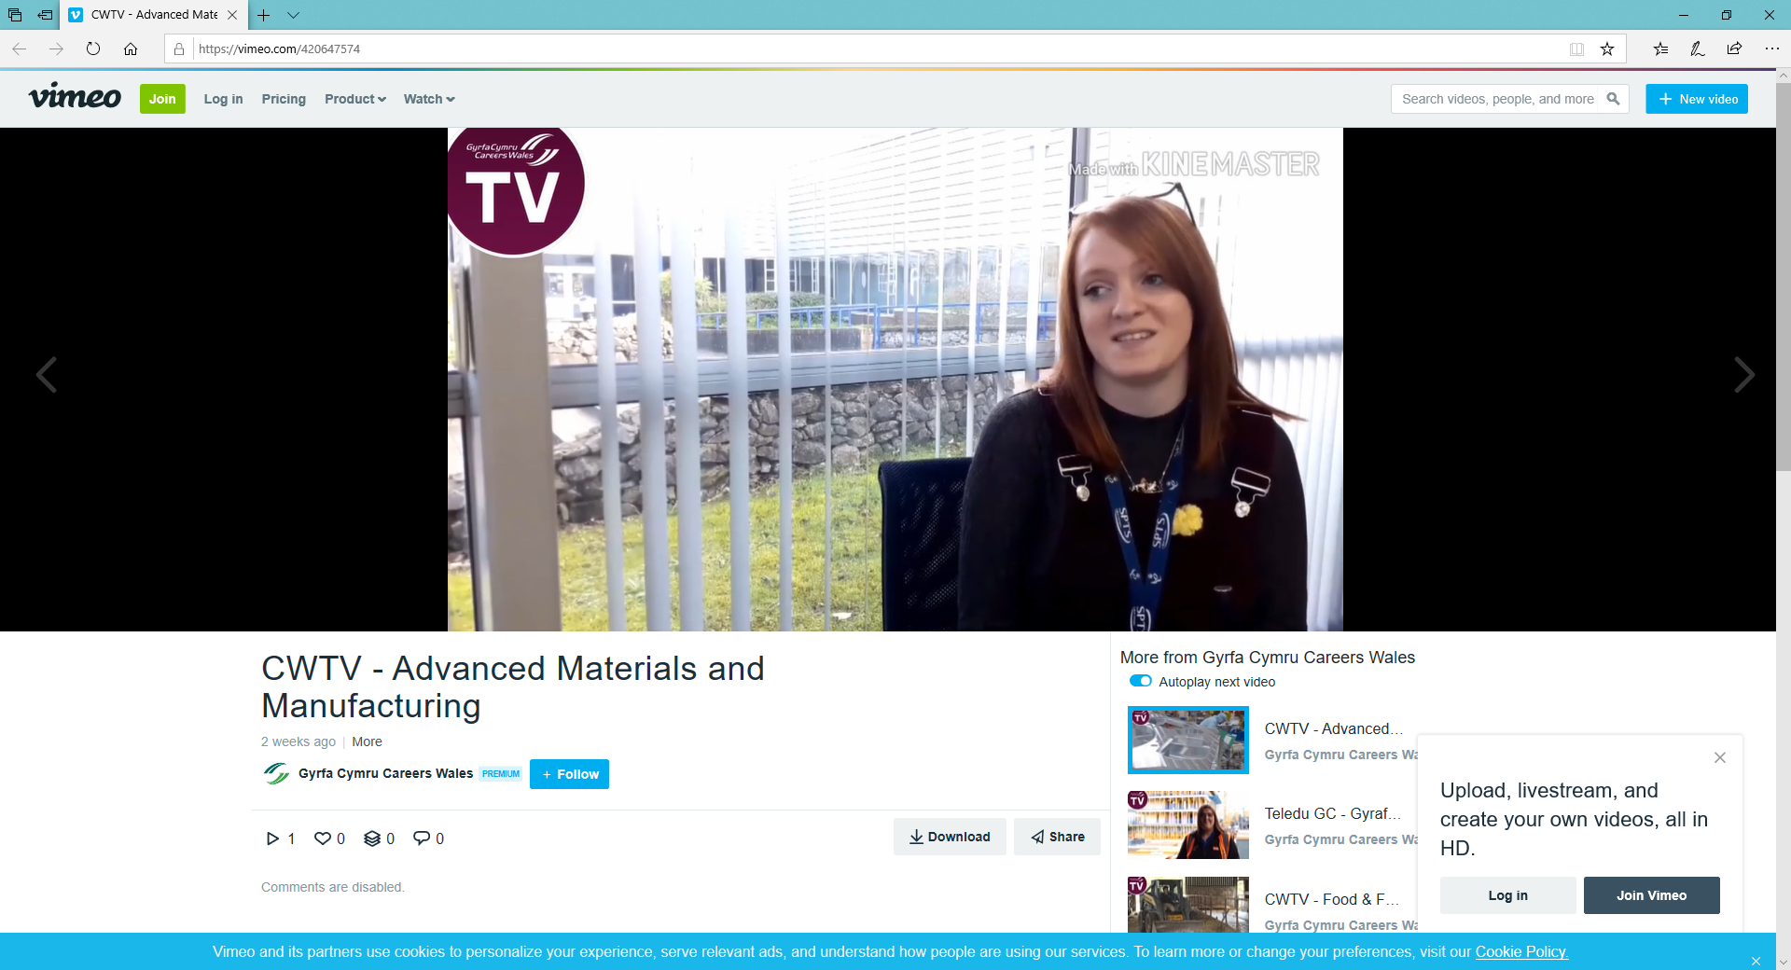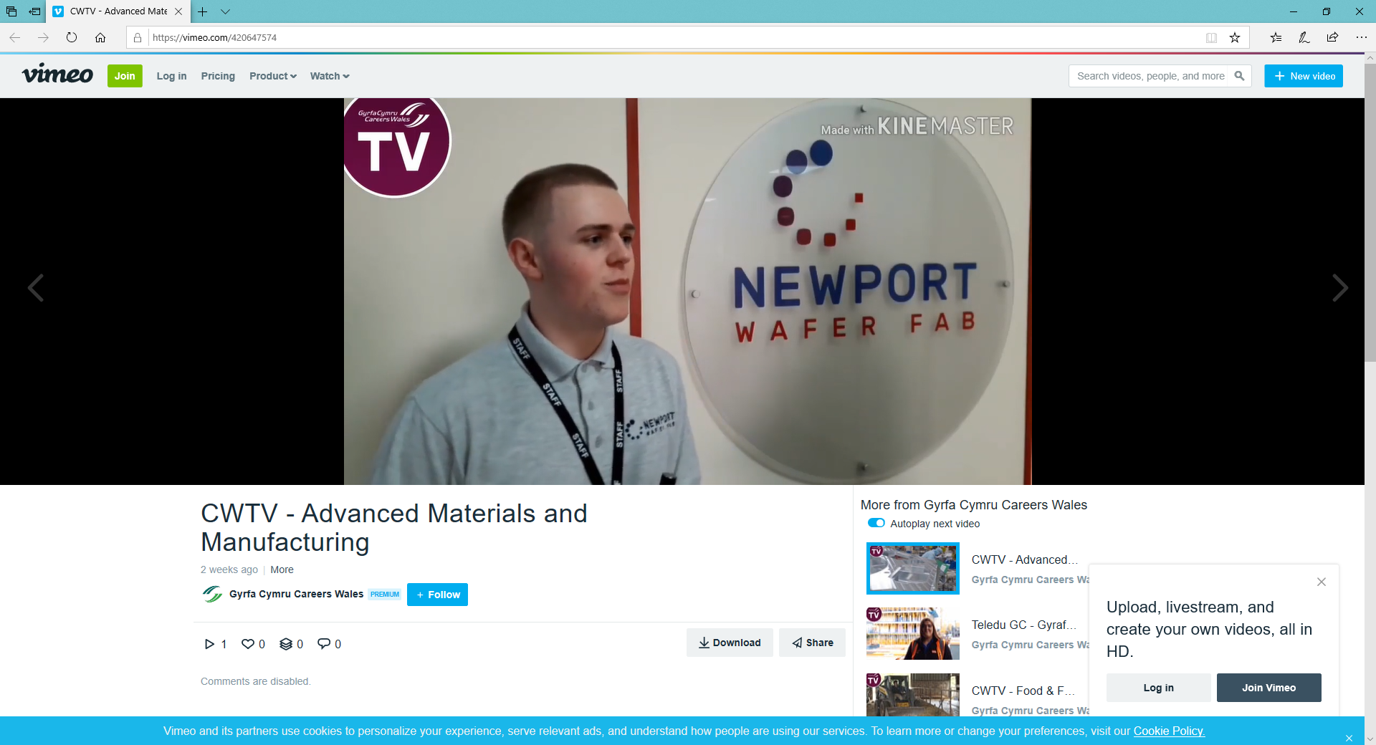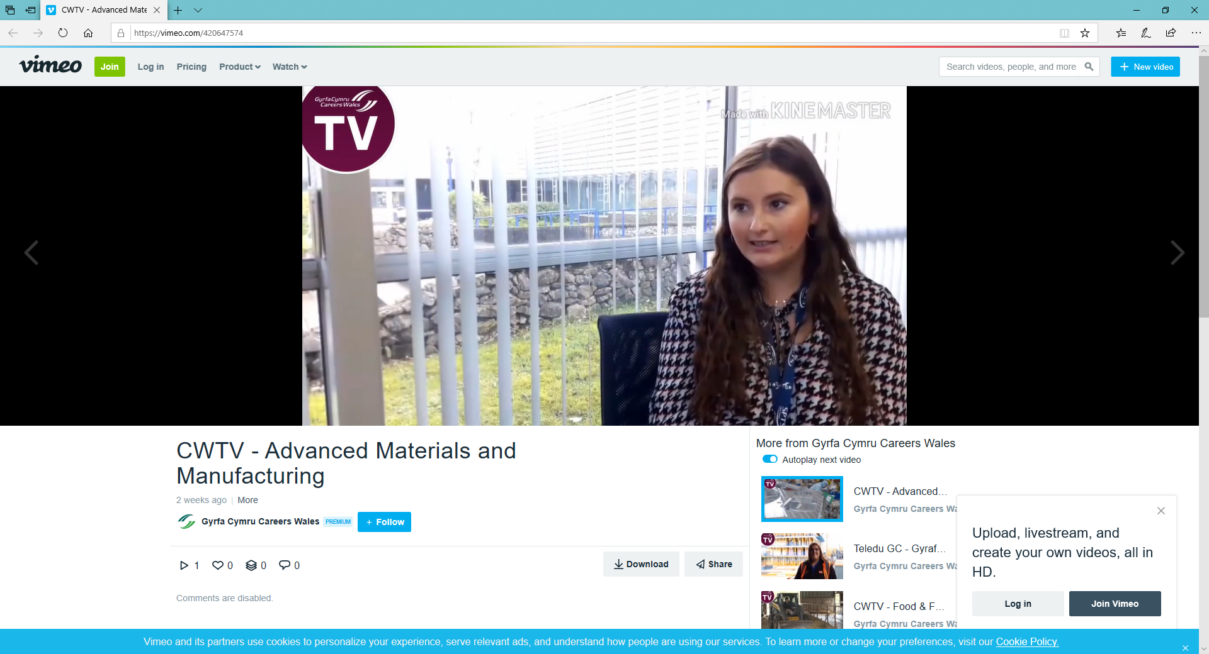

Erin Video 18mins 26 sec

Iowan Video 11mins 7 Sec

Fion Video 17mins 45sec

I have chosen to write about ________________ because,

­

**Research Task**

Research 3 jobs within the Advanced Materials & Manufacturing industry

(e.g. Manufacturing Engineer, Electrical and Electronics Engineer, Production Engineer, Systems Engineer, Test Engineer, Design Engineer).

Briefly describe the job, salary, hours of work, qualifications and skills required, the relevant subjects, and future demand for the job.

Use <https://careerswales.gov.wales/job-information>

Job 1 - …………………………………………………………………………………………………………………………..

……………………………………………………………………………………………………………………………

……………………………………………………………………………………………………………………………

……………………………………………………………………………………………………………………………

……………………………………………………………………………………………………………………………

……………………………………………………………………………………………………………………………

Job 2 -……………………………………………………………………………………………………………………………

……………………………………………………………………………………………………………………………

……………………………………………………………………………………………………………………………

……………………………………………………………………………………………………………………………

……………………………………………………………………………………………………………………………

Job 3 -……………………………………………………………………………………………………………………………

……………………………………………………………………………………………………………………………

……………………………………………………………………………………………………………………………

……………………………………………………………………………………………………………………………

……………………………………………………………………………………………………………………………………………

**Further resources for researching the Advanced Materials & Manufacturing industry:**

**Careers Wales website:** [www.careerswales.gov.wales](http://www.careerswales.gov.wales)

**Finding information on different careers in Advanced Materials & Manufacturing:**

<https://careerswales.gov.wales/job-information>

**Advanced Materials & Manufacturing companies:**

[www.csfusion.org](http://www.csfusion.org)

[www.estnet.uk.net](http://www.estnet.uk.net)

[www.compoundsemiconductorhub.org](http://www.compoundsemiconductorhub.org)

[www.newportwaferfab.co.uk](http://www.newportwaferfab.co.uk)

[www.csa.catapult.org.uk](http://www.csa.catapult.org.uk)

[www.stemcymru.org.uk](http://www.stemcymru.org.uk)

[www.iqep.com](http://www.iqep.com)