Name: …………………………………………………………

Class: ……………………………

Year Group: ……………………………



Before you watch the webinar please answer the following questions:

In your own words what do you think Advanced Materials are?



What skills and qualities do you think an employer in the Advanced Materials & Manufacturing s might want their employees to have?

What skills and qualities do you think an employer in the Advanced Materials & Manufacturing sector might want their employees to have?

What everyday things do we use regularly that require the use of advanced materials?

Now watch the Webinar - <https://vimeo.com/420647574>

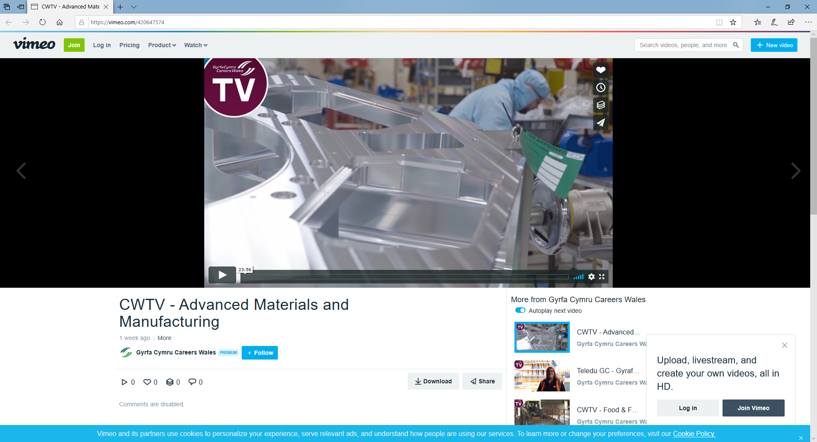

Which sub-areas are important customers for the Advanced Materials & Manufacturing industry?

1. Which area of Wales has the highest concentration of workers in the Advanced Materials & Manufacturing sector?
2. How many people does that relate to?
3. What is the approximate number of people employed in the Advanced Materials & Manufacturing sector in Wales?

Can you name three companies or organisations who are a part of the Compound Semiconductor sector in South Wales?

1.

2.

3.

Can you name three companies or organisations who are a part of the Compound Semiconductor sector in South Wales?

1.

2.

3.

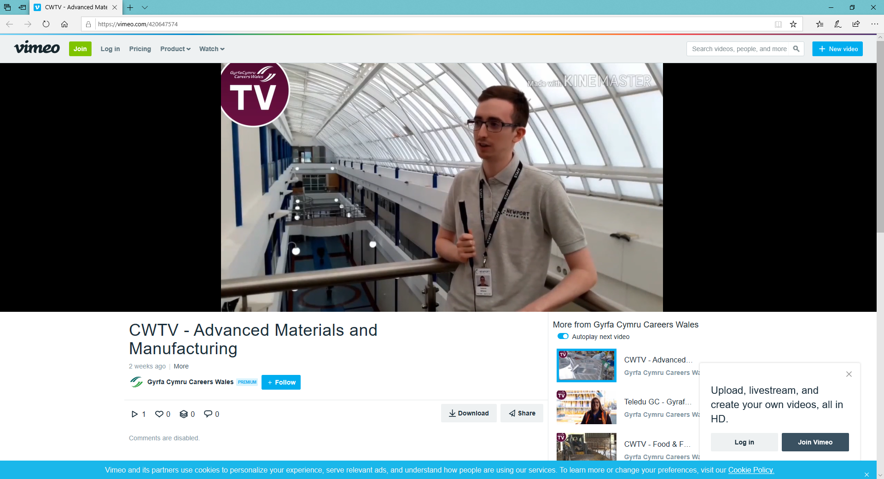

Cameron Williams is an apprentice at Newport Wafer Fab.

1. What qualifications is he working towards?
2. How many days a week does he spend in:
   1. College -
   2. Work -

What are your thoughts about Cameron’s work and study programme, why would it suit you **OR** why would it not suit you?

Choose one of the speakers within the webinar and in your own words write a short piece about them

No more than 150 words

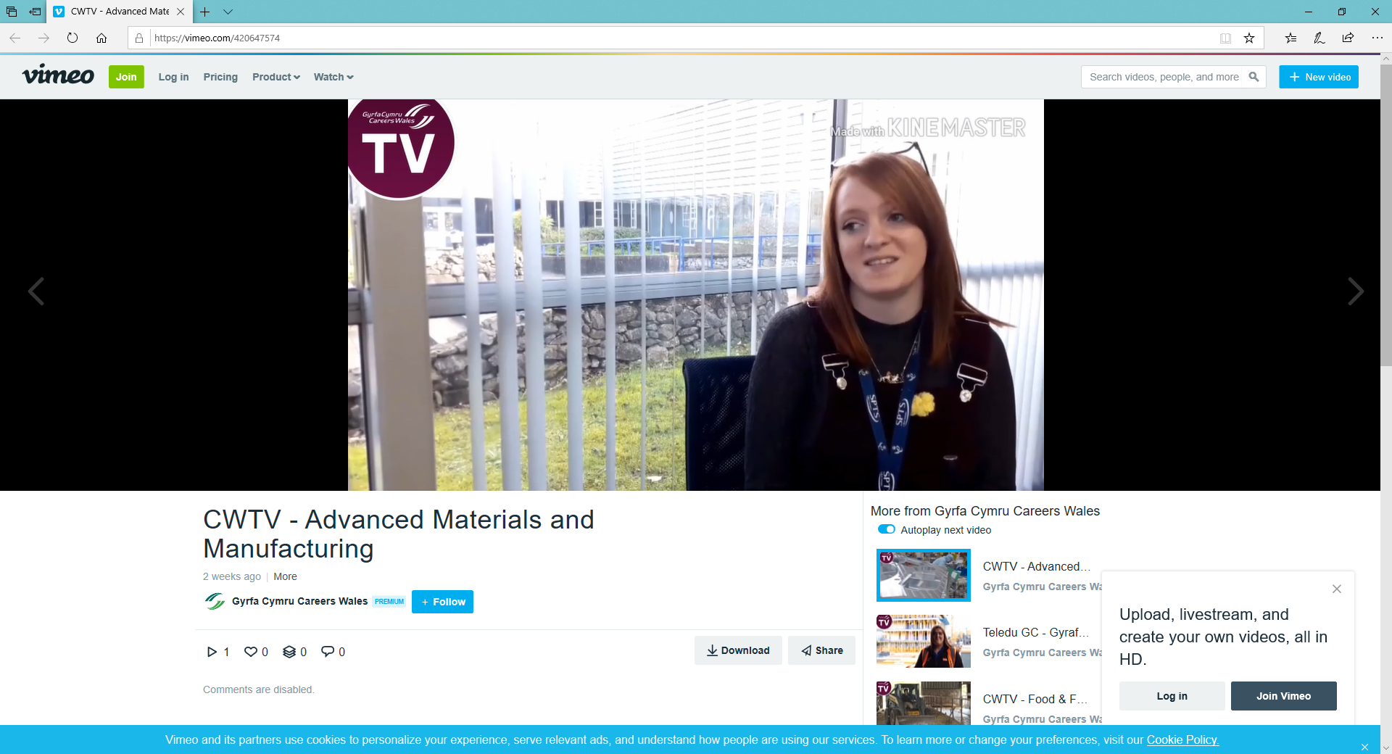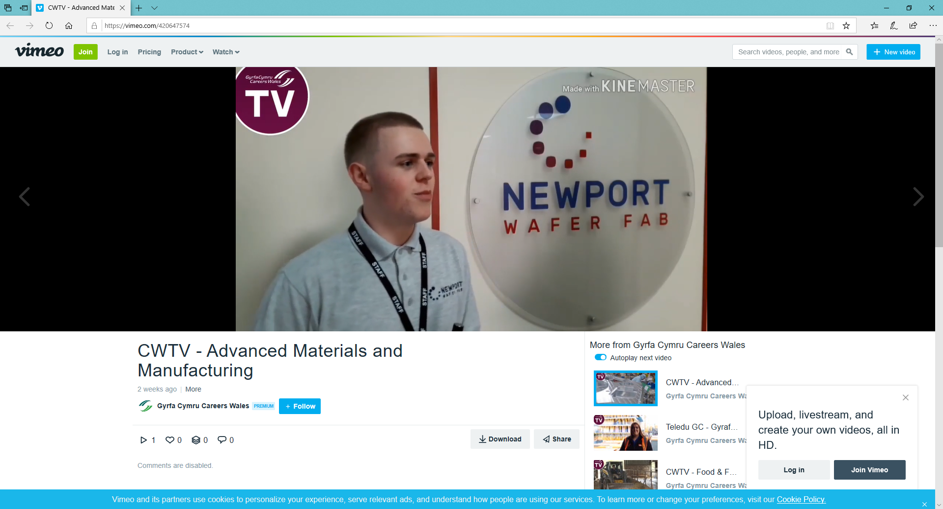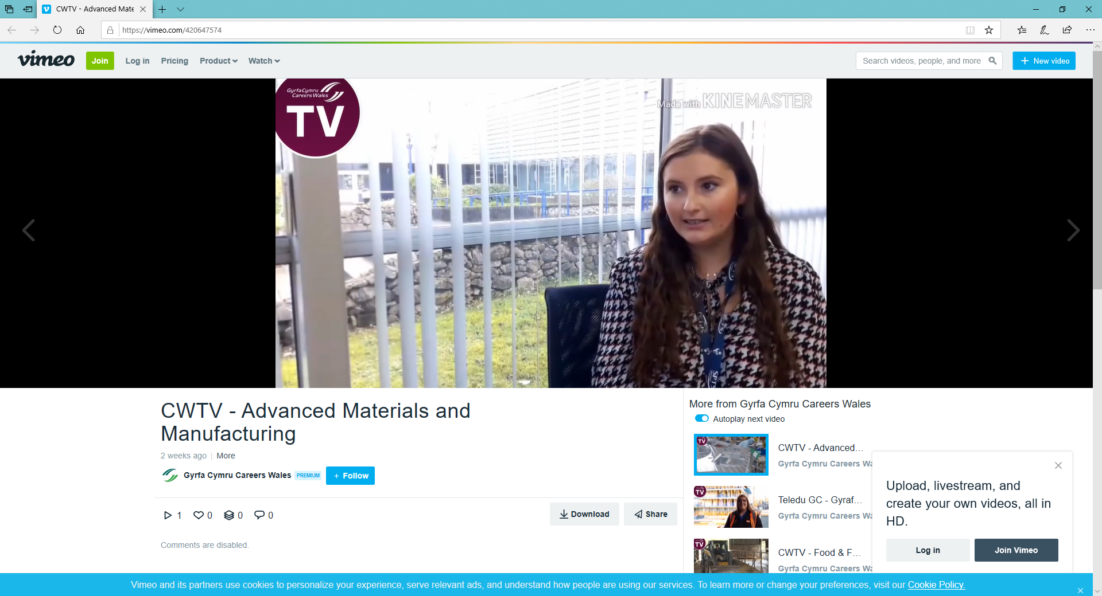

Erin

Iowan

Fion

I have chosen to write about ________________ because,

­

**Research Task**

Research 3 jobs within the Advanced Materials & Manufacturing industry

(e.g. Manufacturing Engineer, Electrical and Electronics Engineer, Production Engineer, Systems Engineer, Test Engineer, Design Engineer).

Briefly describe the job, salary, hours of work, qualifications and skills required, the relevant subjects, and future demand for the job.

Use <https://careerswales.gov.wales/job-information>

Job 1 - …………………………………………………………………………………………………………………………..

……………………………………………………………………………………………………………………………

……………………………………………………………………………………………………………………………

……………………………………………………………………………………………………………………………

……………………………………………………………………………………………………………………………

……………………………………………………………………………………………………………………………

Job 2 -……………………………………………………………………………………………………………………………

……………………………………………………………………………………………………………………………

……………………………………………………………………………………………………………………………

……………………………………………………………………………………………………………………………

……………………………………………………………………………………………………………………………

Job 3 -……………………………………………………………………………………………………………………………

……………………………………………………………………………………………………………………………

……………………………………………………………………………………………………………………………

……………………………………………………………………………………………………………………………

……………………………………………………………………………………………………………………………………………

**Further resources for researching the Advanced Materials & Manufacturing industry:**

**Careers Wales website:** [www.careerswales.gov.wales](http://www.careerswales.gov.wales)

**Finding information on different careers in Advanced Materials & Manufacturing:**

<https://careerswales.gov.wales/job-information>

**Advanced Materials & Manufacturing companies:**

[www.csfusion.org](http://www.csfusion.org)

[www.estnet.uk.net](http://www.estnet.uk.net)

[www.compoundsemiconductorhub.org](http://www.compoundsemiconductorhub.org)

[www.newportwaferfab.co.uk](http://www.newportwaferfab.co.uk)

[www.csa.catapult.org.uk](http://www.csa.catapult.org.uk)

[www.stemcymru.org.uk](http://www.stemcymru.org.uk)

[www.iqep.com](http://www.iqep.com)