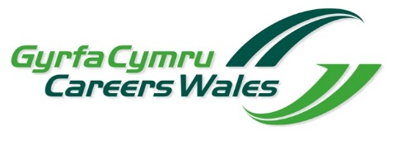

Careers Wales Mark: Continuous Improvement

Self-Evaluation of Careers and the World of Work provision

Establishment:
Author:
Date:

Inspection Area 1: - Standards

In evaluating this area, please consider: -
1.1 Standards and progress overall
1.2 Standards and progress of specific groups
1.3 Standards and progress in skills

How do you know?
Which are the strongest features of Standards, and why?
Which areas require most improvement, and what action is being taken?

Inspection Area 2: Wellbeing and attitudes to learning

In evaluating this key question, please consider: -
2.1 Wellbeing
2.2 Attitudes to learning

How do you know?
Which are the strongest features of Wellbeing and attitudes to learning, and why?
Which areas need most improvement, and what action is being taken?
Inspection Area 3: Teaching and learning experiences

In evaluating this key question, please consider: -
3.1 Quality of teaching
3.2 The breadth, balance and appropriateness of the curriculum
3.3 Provision for skills

How do you know?
Which are the strongest features of Teaching and learning experiences, and why?
Which areas need most improvement, and what action is being taken?

Inspection Area 4: Care, support and guidance

In evaluating this key question, please consider: -
4.1 Tracking, monitoring and the provision of learning support
4.2 Personal development
4.3 Safeguarding

How do you know?
Which are the strongest features of Care, support and guidance, and why?
Which areas need most improvement, and what action is being taken?

Inspection Area 5: Leadership and management

In evaluating this key question, please consider: -
5.1 Quality and effectiveness of leaders and managers
5.2 Self-evaluation processes and improvement planning
5.3 Professional learning
5.4 Use of resources

How do you know?
Which are the strongest features of Leadership and management, and why?
Which areas need most improvement, and what action is being taken?

Appendix

Estyn’s guiding principles

