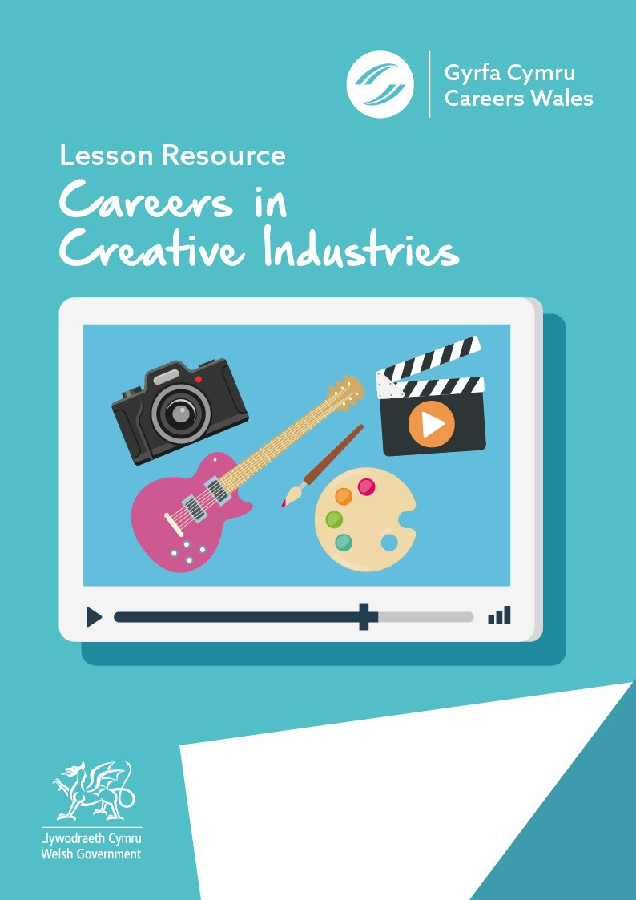

Answer Sheet

Before you watch the webinar please answer the following questions:

In your own words what is your understanding of the Design sector:
Answer will vary depending on individual

What skills and qualities do you think you need to work as a Designer ?
creative design skills
an understanding of technical and production processes
good organisation and planning skills
good communication, presentation and negotiation skills
problem-solving skills
to work to deadlines and budgets
good research skills

Hint:
EN: https://careerswales.gov.wales/job-information/vehicle-designer

Now watch the Video - https://vimeo.com/378563320/25e2bf2425

Now you have seen the video can you answer the following questions?
What does Liz the presenter do for a job ? (video 16s)
Freelance Graphic Designer and Illustrator

What percentage of the workforce in Wales is employed in Creative Industries ? (video 1min 35 s)

4%
6%
10%

Can you name 3 jobs in the design sector?
1. – Product Design
2. – Graphic Design
3. – Games Design
(Video 2mins 5s)

True or False?
One third of Creative jobs in Wales are based in Cardiff?
TRUE
(Video 2mins 15 s)
What is meant by the word "Design"?

Design is working to solve problems using creative skills.

Ryan mentions that he is a Trainee Architectural Technologist, but which subjects did he study in school? (Video 8mins 55s)

Design and Technology (Graphics)
ICT
Art & Design

Find out more - https://careerswales.gov.wales/job- information/architectural-technologist

Izzie is a Junior Designer at Storm and Shelter, what type of person did she mention she was in school?

Really Creative
Hint – video at 18mins 56secs

What job role is most common at ‘Do Digital Agency’? (video at 21mins 13s)

3D Artist

Tick which routes you can follow to enter the design industry Apprenticeship
Degree
Both of the above
Which of the people who took part in the webinar do you most relate to and why?
Izzie - Junior Designer at Storm and Shelter Ceri – Creative Director at Do Digital Agency Alex – Head of Design at Storm and Shelter
Ryan – Trainee Architectural Technologist at T. Richard Jones

Finally, having watched the webinar what are your thoughts
about a career in Design?

Further resources for Creative Sector research:

Careers Wales website – www.careerswales.gov.wales Finding information on different careers in design - https:// careerswales.gov.wales/job-information
Creative & Cultural Skills (Sector Skills Council) - https:// ccskills.org.uk/

Companies featured in the Webinar:

Do Digital Agency - https://dodigitalagency.com/
Storm and Shelter - https://stormandshelter.com/
T. Richard Jones - https://www.trjltd.co.uk/ Liz (presenter) - https://chipperdesigns.org

