**Answer Sheet**

Name: …………………………………………………………

Class: ……………………………

Year Group: ……………………………



Farming in Wales contributes significantly to the Food & drink Industry for the UK. How much do you think the Food & drink Industry is worth?

The Food & Drink Industry in the UK is worth £6billion

Source: www.nfu-cymru.org.uk

What are some of the benefits of working in the Food & farming Sector?

Some ideas include:

Outdoor working, Physical fitness, work with animals & Livestock, operate heavy machinery, work on your own initiative, contribute to one of Wales’ biggest Sectors.

Please watch the webinar: [CWTV Webinar 11 - Food & Farming](https://careerswalesccdg.sharepoint.com:443/:v:/s/DigitalInnovationTeam-FinishedProducts/EWCj6sP-Q_dNjgUs95HiM8sB8kUry-q8GSLvW_KSeb8TJw?e=4%3aBt436x&at=9)

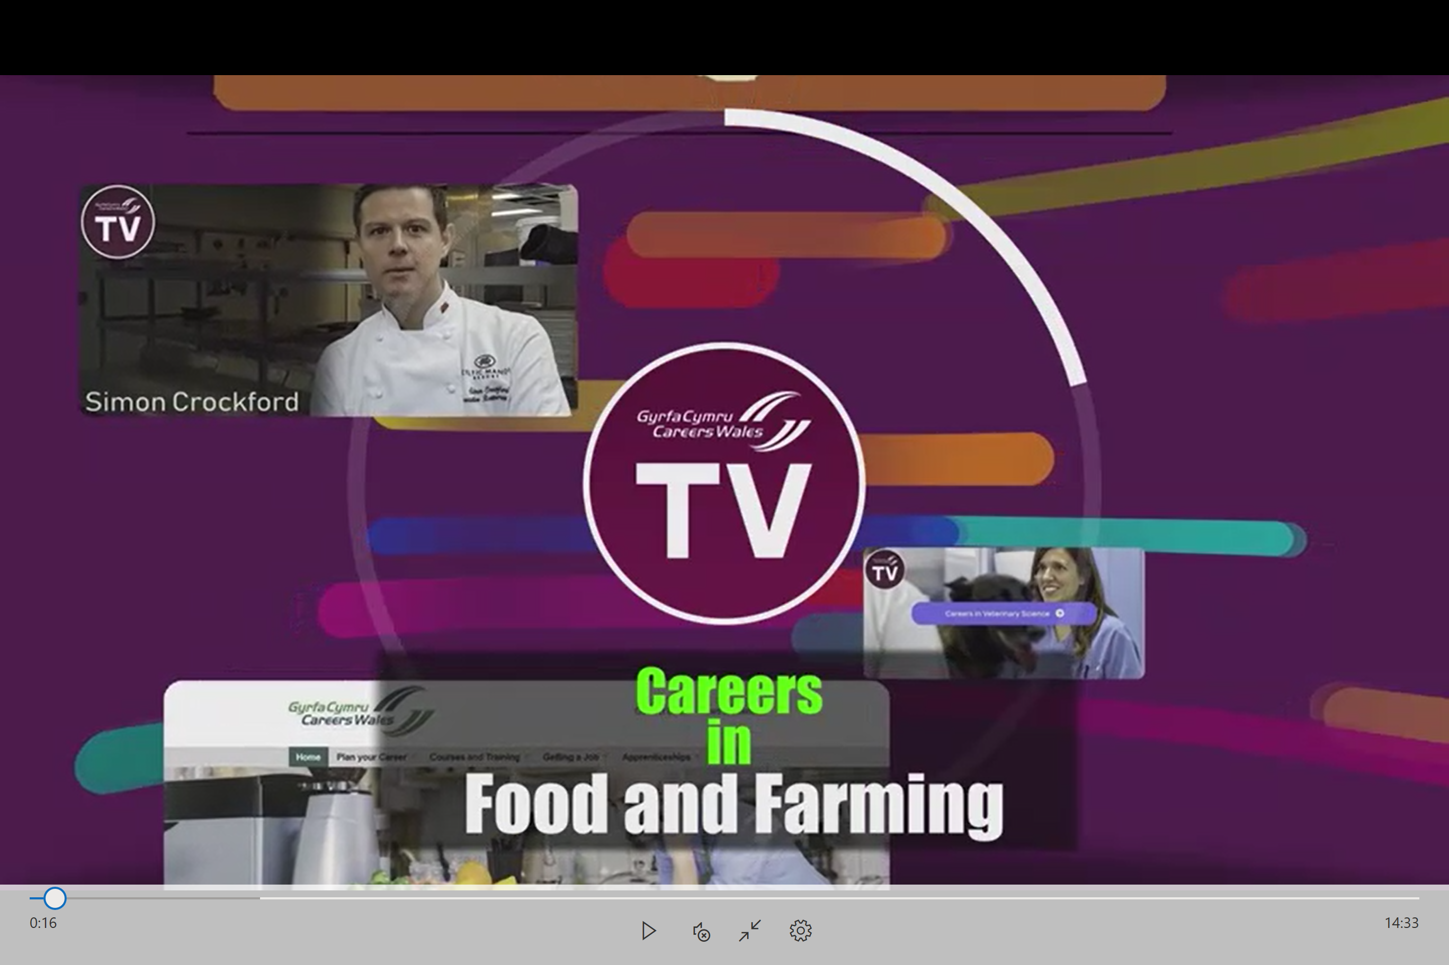

Name 3 Personal effectiveness skills an employer would look for in this Sector?

Choose between: Organisation, Good communication, Understanding basic commands, Good timekeeping, Reliable, Polite, Pro Active

How many staff at Genus are educated to at least degree level?

50% of the staff employed at Genus hold a Degree level Qualification.

What types of Qualifications would you need to work in this sector?

To work in this Sector, you will need one or more of the following Qualifications:

BTEC, Diploma, GCSE Level Qualifications, Degree in a Science related subject

What types of roles are available at Genus?

Production Staff, Vets, Laboratory Staff, Technicians & Sales Staff are all employed at Genus.

What are the Key Skills an employee of Genus should have?

You would be required to have: Good attention to detail, a passion for the Industry and be a Team Player.

What GCSE and A-Level subjects did our panel member Meghan study at school?

Meghan told us she chose Science-based subjects, ICT, History & Geography at GCSE and A-Level. Meghan completed a Bio-Veterinary Science Degree to complete her studies at University.

What are the salary ranges at Genus?

The Salaries offered at Genus range between £17,000 a year for the basic roles e.g. Customer Service/Administration, up to £30,000 - £50,000 a year for the Management Roles in the company.

What impact might Brexit have on the Industry?

* Importing less meat & Dairy products into the UK
* Exports will decrease

What are the types of future jobs within the farming Industry?

* Staff across all Departments at Genus due to an increase in demand
* Scientific Research roles to develop Technology across the Industry

Name 2 things which are important if you want to work in the Food & Farming Industry?

Good Education (results), Experience such as YFC/Farming Connect, College or University Courses

What is the main point you will take from watching this Webinar?

Pupil’s own interpretation and learning.

