Name: …………………………………………………………

Class: ……………………………

Year Group: ……………………………



Farming in Wales contributes significantly to the Food & drink Industry for the UK. How much do you think the Food & drink Industry is worth?

What are some of the benefits of working in the Food & farming Sector?

Please watch the webinar: [CWTV Webinar 11 - Food & Farming](https://careerswalesccdg.sharepoint.com:443/:v:/s/DigitalInnovationTeam-FinishedProducts/EWCj6sP-Q_dNjgUs95HiM8sB8kUry-q8GSLvW_KSeb8TJw?e=4%3aBt436x&at=9)

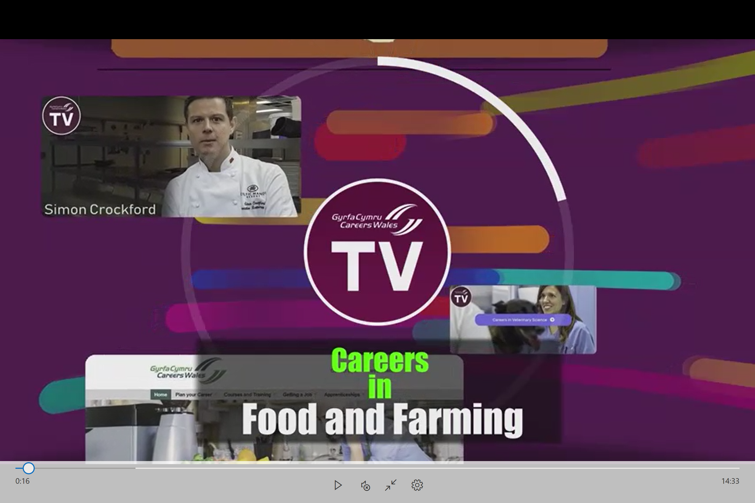

Name 3 Personal effectiveness skills an employer would look for in this Sector?

How many staff at Genus are educated to at least degree level?

What types of Qualifications would you need to work in this sector?

What types of roles are available at Genus?

What are the Key Skills an employee of Genus should have?

What GCSE and A-Level subjects did our panel member Meghan study at school?

What are the salary ranges at Genus?

What impact might Brexit have on the Industry?

What are the types of future jobs within the farming Industry?

Name 2 things which are important if you want to work in the Food & Farming Industry?

What is the main point you will take from watching this Webinar?

