Answer Sheet

Before you watch the webinar please answer the following questions:

In your own words what jobs exist in the Health Sector:

Answer will vary depending on reader’s interpretation.

What skills and qualities do you think you need to work in Health?

Answer will be reader’s current knowledge before watching the webinar

Now watch the webinar -
https://vimeo.com/user100455112/review/379237744/d2d6242970
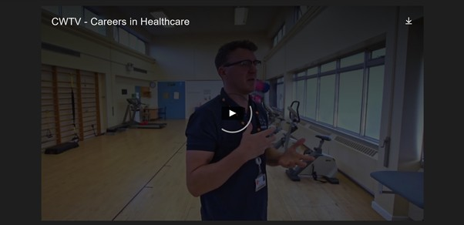

How many people work in the NHS in Wales?

Nearly 80,000 people were employed by the NHS in Wales last year

There are approximately 350 different roles in the NHS
How many different roles are there in the NHS? There There are approximately 350 different roles in the NHS in Wales

In your own words, what does a Physiotherapist do?

Reader’s own interpretation

What Qualifications do you need to become a Physiotherapist?

You will need a minimum of 5 GCSE’s A-C grades including Maths, Science and English/Welsh (If working/studying in Wales)
You will also need 3 A-Levels and a Degree in Physiotherapy

In your own words, explain why Welsh in the Workplace is important?
Reader’s interpretation – Hint: One of the Webinar panel members has a job linked to this answer

In your opinion to work in the Health sector, employers are looking for people with which of the following required skills -
Answer:
- Compassion
- Excellent communication skills
- Problem Solving
- Team player

- Compassion
- Innovative
- Team player
- Be able to work on your own
- Problem solving
- Excellent communication skills

In your own words what is your understanding of the role of a Pharmacist?
Reader’s own interpretation – Hint: Look out for the Pharmacist during the video clip
To become a Pharmacist, you will need a Degree in Pharmacy – 4 years + 1 year Post-Graduate study
mum.

What qualifications do you need to become a Pharmacist?

What sort of starting salary would you expect a newly
qualified Nurse in the NHS to earn?
£24,214 starting salary per year
which is equivalent to £465.65 per week.

Where do Paramedics Train in Wales?
The Paramedic training in Wales takes place in Swansea University

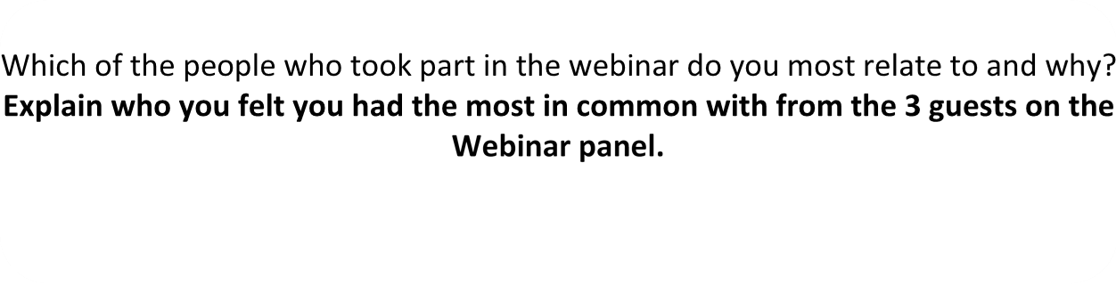

Finally, in your own words what are your thoughts about a career in the Health sector and why?

Readers Interpretation

Further resources for Health sector research:

Careers Wales website – www.careerswales.gov.wales
NHS Wales Careers Site – www.weds.wales.nhs.uk/nhs-wales- careers
Train Work Live – www.trainworklivenorthwales.co.uk/
NHS Jobs – www.jobs.nhs.uk/

