Name: …………………………………………………………

Class: ……………………………

Year Group: ……………………………

Before you watch the webinar please answer the following questions:

In your own words what jobs exist in the Health Sector:

What skills and qualities do you think you need to work in the Health Sector?

Now watch the webinar -
https://vimeo.com/user100455112/review/379237744/d2d6242970
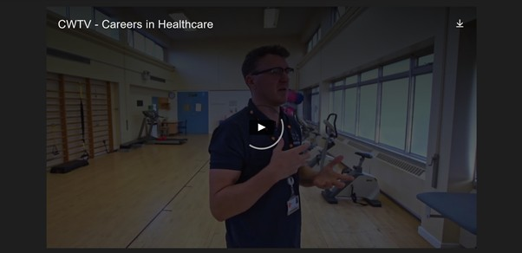

How many people work in the NHS in Wales?
How many different roles are there in the NHS?

In your own words, what does a Physiotherapist do?

What Qualifications do you need to become a Physiotherapist?

In your own words, explain why Welsh in the Workplace is important?

In your opinion, to work in the Health sector, employers are looking for people with which of the following required skills -

- Compassion
- Innovative
- Team player
- Be able to work on your own
- Problem solving
- Excellent communication skills

In your own words, what is your understanding of the role of a Pharmacist?
What qualifications do you need to become a Pharmacist ?

Where do Paramedics study in Wales ?

What sort of starting salary would you expect a newly qualified Nurse in the NHS to earn? £

How much does that work out per week? £

Finally, in your own words what are your thoughts about a career in the Health sector and why?

Which of the people who took part in the webinar do you most relate to and why?

Further resources for Health sector research:

Careers Wales website – www.careerswales.gov.wales
NHS Wales Careers Site – www.weds.wales.nhs.uk/nhs-wales- careers
Train Work Live – www.trainworklivenorthwales.co.uk/
NHS Jobs – www.jobs.nhs.uk/

