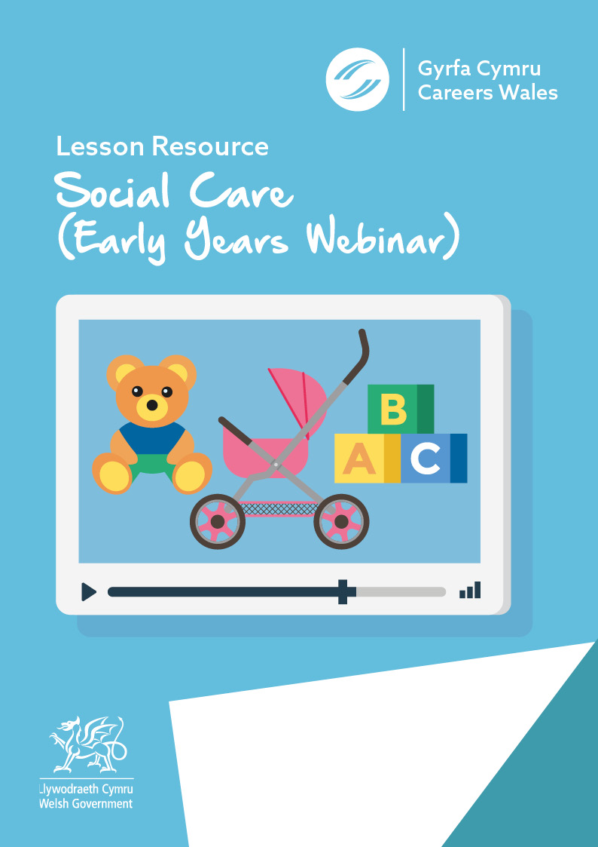

Answer Sheet

Before you watch the webinar please answer the following questions:

In your own words, what is your understanding of the Early Years Social Care Sector?:
Answers will vary depending on individual.

What skills and qualities do you think you need to work in Social Care - Early years ?
Answers will vary depending on individual.

Now watch the Video - https://vimeo.com/378587764/a197547735
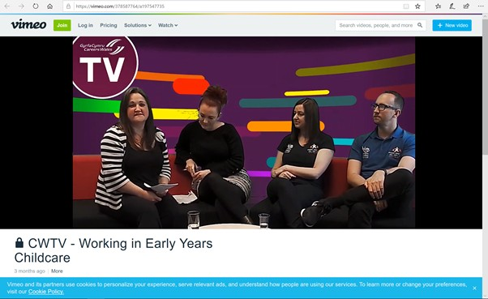

What does the care sector incorporate? In your opinion what kind of job roles do you think come into those two areas?
Early Years Care + Elderly Adult Social Care +
Answers of opinion will vary depending on individual
List the types of roles there will be demand for in future in this sector? 1 Play Workers
2 Nursery Nurses

3 Nannies

4 Childminders
What is Flying Start and what do they do?

Flying Start has been running since 2007. It has 4 strands – Childcare, Parenting Programme, Enhanced Health-visiting and Speech & Language.
In the childcare section they deal with creches (0-4yrs) and childcare settings (e.g.playgroup – 2.5hrs a day, Monday to Friday in certain postcode areas)

Which of the following statements about a Flying Start Senior Practitioner are correct? (highlighted)
- They enable provision for individuals with Additional Learning Needs
- They work directly with the children at all times
- They’re trained to deal with Safeguarding issues, First Aid etc
- They manage the day to day running of the setting

What are the benefits of an apprenticeship in the Social Care/Early Years sector?

Additional Learning Needs Practitioners would work on a 1:1 or 1:2 ratio with children rather than look after the whole group. They would support an individual child/small number of children with their varied needs, such as medical, behaviour etc

Name three types of clubs that Clybiau Plant Cymru Kids Clubs provide –

Breakfast Club,
After school club,
Holiday Club

List three ways you could easily get into roles within this sector.
- Health & Social Care Qualification
- Apprenticeship
- Volunteering

2
3

What is the salary range for these types of roles within the Early Years Sector?
£16,000 - £25,000

Answers will vary depending on individual
Finally, what are your thoughts about a career in Social Care
-Early Years?

Further resources for Social Care – Early Years research:

Careers Wales website – www.careerswales.gov.wales
Nanny Job Information - https://careerswales.gov.wales/job-information/nanny
Care Home Manager Job Information - https://careerswales.gov.wales/job-information/care-home-manager
Wecare Wales - https://www.wecare.wales/working-with-children/
Gofalwn Cymru https://www.gofalwn.cymru/gweithio-gyda-phlant/
List of qualifications needed for Social Care – Early Years in Wales https://socialcare.wales/cms_assets/file-uploads/List-of-required-qualifications-to-work-within-early-years-and-childcare-sector-in-Wales.pdf

