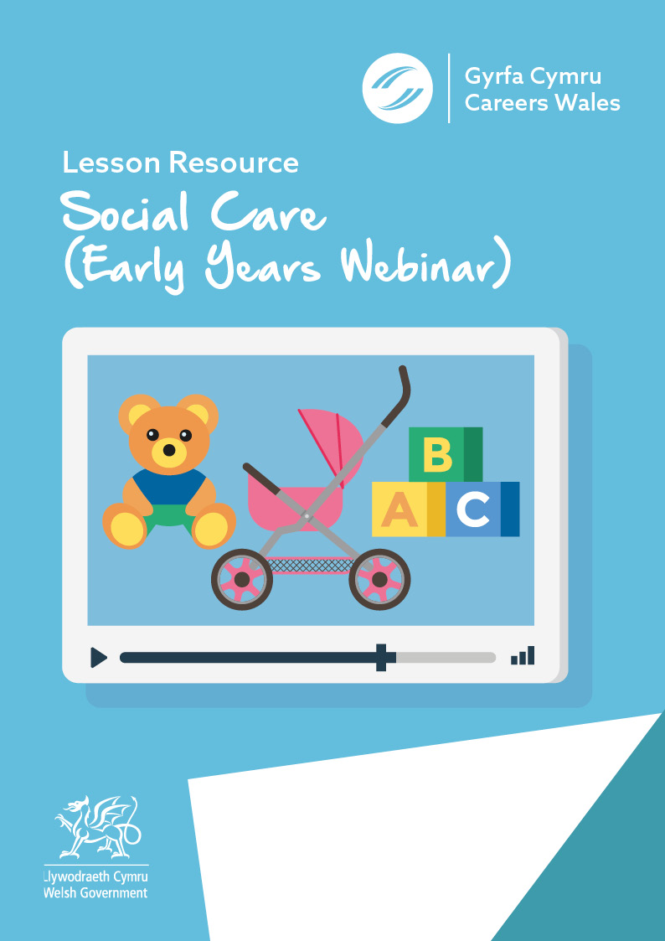

Name: …………………………………………………………

Class: ……………………………

Year Group: ……………………………

Before you watch the webinar please answer the following questions:

In your own words, what is your understanding of the Early Years & Social Care sector?

What skills and qualities do you think you need to work in Early Years & Social Care?

Now watch the Video - https://vimeo.com/378587764/a197547735
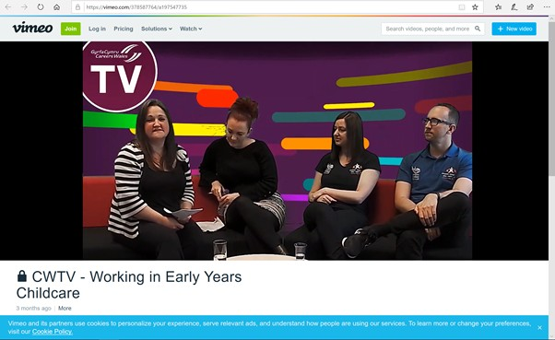

What does the care sector incorporate? In your opinion, what kind of job roles do you think come into those two areas?
List the roles there will be a demand for in the future in this sector?
1.
2.

3.

What is Flying Start and what do they do ?
Which of the following statements about a Flying Start Senior Practitioner are correct ?
- They enable provision for individuals with Additional Learning Needs
- They work directly with the children at all times
- They are trained to deal with Safeguarding issues, First Aid etc
- They manage the day to day running of the setting

What are the benefits of an apprenticeship in the Early Years & Social Care sector?

Name three types of clubs that Clybiau Plant Cymru Kids Clubs provide –

List three ways you could easily get into roles within this sector.
1.
2.
3.

What is the salary range for these types of roles within the Early Years Sector??

Finally, what are your thoughts about a career in Social Care
-Early Years?

Further resources for Social Care – Early Years research:

Careers Wales website – www.careerswales.gov.wales
Nanny Job Information - https://careerswales.gov.wales/job-information/nanny
Care Home Manager Job Information - https://careerswales.gov.wales/job-information/care-home-manager
Wecare Wales - https://www.wecare.wales/working-with-children/
Gofalwn Cymru https://www.gofalwn.cymru/gweithio-gyda-phlant/
List of qualifications needed for Social Care – Early Years in Wales https://socialcare.wales/cms_assets/file-uploads/List-of-required-qualifications-to-work-within-early-years-and-childcare-sector-in-Wales.pdf

