Name: …………………………………………………………

Class: ……………………………

Year Group: ……………………………



Before you watch the webinar please answer the following questions:

2) What skills and qualities do you think you need to be a Production Assistant?

1. What is the expected future demand for Television Presenters?

A: High

B: Medium

C: Low

**Now watch the webinar** –

<https://vimeo.com/419879767>

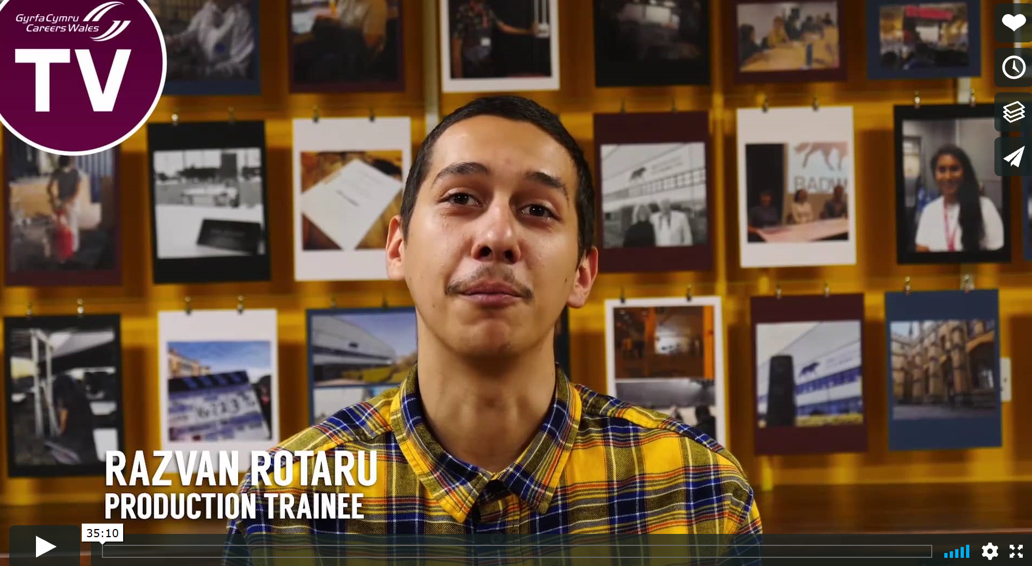

3) How many TV & Film-related courses are offered by University of South Wales (USW)?

4) What is the name of the production company studio behind ‘His Dark Materials’

1. Big Wolf Productions
2. Bad Dog Productions
3. Bad Wolf Productions

5) Which course did Sarah study at USW?

1. TV & Filmset Design
2. Production Assistant
3. Graphic Design

5

6) What are some of the diverse careers within the TV and Film industry?

7) what is the name of the training provider linked to the TV and Film industry in Wales?

8) Name one of the organisations that offer TV and Film-related apprenticeships in Wales?

9) What was Andrew’s first role in the industry?

1. Runner
2. Actor
3. Presenter

10) Name one role that could lead to a career as a Producer?

11) What is the minimum age for a work experience placement at Screen Alliance Wales?

12) What is the best way to get into acting?

**Further resources for research:**

Careers Wales website – [www.careerswales.gov.wales](http://www.careerswales.gov.wales)

Into Film Programme - <https://www.intofilm.org/>

University of South Wales - <https://www.southwales.ac.uk/filmschool/>

Screen Alliance Wales - <https://www.screenalliancewales.com/>

Apprenticeships - <https://www.sgilcymru.com/en/apply-now/>

Bafta Wales - <http://www.bafta.org/wales>

Finally, in your own words what are your thoughts about a career in the TV and Film industry?