Name: …………………………………………………………

Class: ……………………………

Year Group: ……………………………



Before you watch the webinar please answer the following questions:

**What are some of the benefits of working in the tourism industry?**

**Answer**: A good work/life balance **-** flexible and part time hours in some posts. Lots of opportunities to progress -opportunities to enter on the ground floor and work your way to the very top. Variety -lots of different experiences and opportunities, so no two days are the same. Working with people -work and learn as part of a team. Source: <https://businesswales.gov.wales/skillsgateway/tourism>

**The tourism industry is a major contributor to the economy of Wales; how much money do you think tourists spend in Wales each year?**

**Answer**: Tourists spend around £17 million a day whilst in Wales, amounting to around £6.3 billion a year.

Source: <https://businesswales.gov.wales/tourism/>

**Now watch the webinar** - <https://vimeo.com/426278427>

[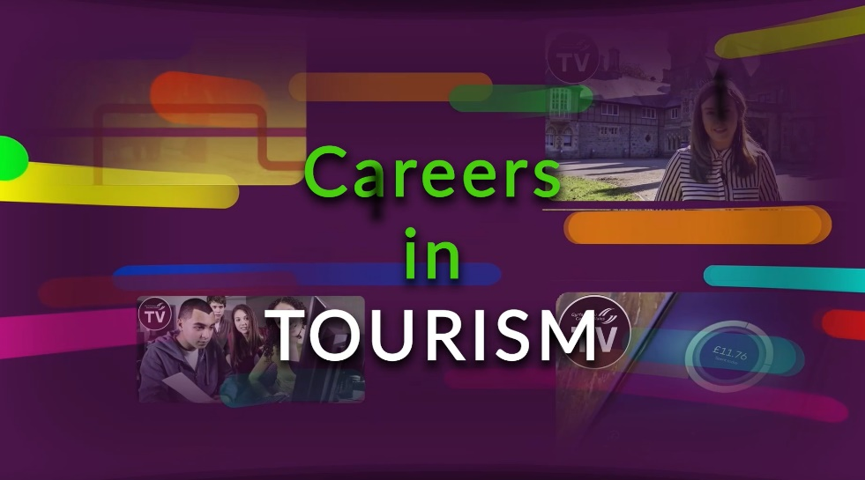](https://vimeo.com/426278427)

**What is the role of Visit Wales?**

**Answer:** Visit Wales is Welsh Government’s tourism department. Their role is to attract visitors to Wales, to ensure they have an amazing experience while in Wales and to encourage visitors to stay in Wales for a long time. They also work with tourism businesses to help ensure they offer a fantastic visitor experience so people will come back again.

**List 3 of the courses available from the Department of Tourism, Hospitality and Events Management at Cardiff Metropolitan University, as mentioned in the webinar by Dr Sheena Carlisle:**

**Answer:**

Undergraduate degrees in Event Management, International Hospitality Management & International Tourism Management

Postgraduate (Masters) degrees in Event Project Management and Hospitality & Tourism Management

**What are some of the main job responsibilities for Kieran Russell, Team Leader of Adrenaline Indoors at Adventure Parc Snowdonia?**

**Answer:** As a team leader, Kieran’s role includes managing staff rotas, ensuring the team get to work on time and staff development to help ensure team members are progressing through the business. He also supports the coordinators with the daily running of the business.

**What are some of the benefits of starting an apprenticeship in the tourism sector?**

**Answer**: There are lots of businesses within the tourism and hospitality sector that offer apprenticeships. Apprenticeships are available at different levels; you can start an apprenticeship with no qualifications. Employers value enthusiasm, having a genuine interest and a willingness to learn. Through an apprenticeship programme you will learn new skills, gain valuable experience, complete on the job training, and receive a salary.

**What support is available for people who would like to set up their own business in the tourism sector in Wales?**

**Answer**: Business Wales provides one-to-one support and advice for people interested in setting up their own business. Support is available at every stage from the planning and start-up of a business and will include financial advice and continuous support to help the business grow.

**Businesses within the tourism sector are increasingly using digital media and new technologies to maximise the visitor experience; can you identify some examples of how businesses in Wales use digital media and new technologies such as augmented reality?**

**Examples include:**

Wales Coast Path App (<https://www.walescoastpath.gov.uk/>), Cadw App (<https://cadw.gov.wales/app>), Bluestone National Park Resort, Pokémon Go (<https://www.bluestonewales.com/blog/pokemon-go-guide>), Immotion VR at St David’s Shopping Centre, Cardiff (<https://immotionvr.com/experiences/>), Alice in Wonderland Trail, virtual reality app, Llandudno (<https://www.visitwales.com/things-do/culture/cultural-attractions/alice-wonderland-tour-llandudno>). Also see virtual reality videos across Wales (<https://www.visitwales.com/inspire-me/days-out/wales-360deg-videos>)

**Anglesey Sea Zoo is primarily a tourism business, but what else do they do?**

**Answer**: As well as being an important tourist attraction on Anglesey, the Sea Zoo also participates in education work, conservation activities, research, and hands on community work such as beach cleaning and animal rescue

**What is unique about the location of Anglesey Sea Zoo?**

**Answer**: Anglesey Sea Zoo is located on the edge of the Menai Strait and is therefore able to pump natural sea water through their exhibits; only 4 other aquariums in the world can do this. As a result of this natural system, Anglesey Sea Zoo specialises in native British species and breeding several endangered species.

**Frankie Hobro, Director & Owner of Anglesey Sea Zoo, employs a wide range of staff including volunteers; what are some of the benefits of volunteering in the tourism sector?**

**Answer:** Volunteering is a great way to find out if you enjoy and are suited to different job roles. Volunteering also helps you to gain valuable experience, to learn new skills, to meet new people and to give something back to society and to help others.

**List 4 of the key skills & qualities required to work in the tourism sector:**

**Answer:** Enthusiasm / Interest, Willingness to Learn, Communication Skills & Team Working Skills. Having some work experience is also highly beneficial.

**What does the ‘MICE’ acronym stand for in the context of the tourism sector**?

**Answer**: MICE stands for: Meetings, Incentives, Conferences & Exhibitions and is an increasing market in the tourism sector in Wales.

**Further resources for research**

**Careers Wales:** [www.careerswales.gov.wales](http://www.careerswales.gov.wales)

**A-Z job information:** <https://careerswales.gov.wales/job-information>

**Employers that offer apprenticeships:** <https://careerswales.gov.wales/apprenticeships/employers-who-offer-apprenticeships>

**Careers Wales YouTube Channel:** <https://www.youtube.com/channel/UCQ3nLYkcm8I_ksdk2QaBQ0g>

**Visit Wales:** <https://www.visitwales.com/>

**Cardiff Metropolitan University – School of Tourism, Hospitality & Events Management:** <https://www.cardiffmet.ac.uk/management/Pages/Tourism,-Hospitality-and-Events-Management.aspx>

**Business Wales:** <https://businesswales.gov.wales/>

**Businesses featured in the webinar**

**Harbour Master Hotel, Aberaeron:** <https://harbour-master.com/>

**Adventure Parc Snowdonia:** <https://www.adventureparcsnowdonia.com/>

**Anglesey Sea Zoo:** <https://www.angleseyseazoo.co.uk/>