Name: …………………………………………………………

Class: ……………………………

Year Group: ……………………………



Before you watch the webinar please answer the following questions:

**What are some of the benefits of working in the tourism industry?**

**The tourism industry is a major contributor to the economy of Wales; how much money do you think tourists spend in Wales each year?**

**Now watch the webinar** - <https://vimeo.com/426278427>

[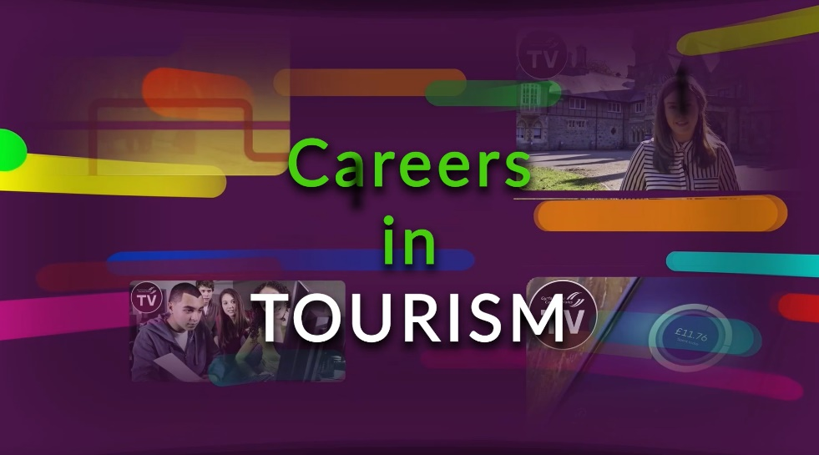](https://vimeo.com/426278427)

**What is the role of Visit Wales?**

**List 3 of the courses available from the Department of Tourism, Hospitality and Events Management at Cardiff Metropolitan University, as mentioned in the webinar by Dr Sheena Carlisle:**

**What are some of the main job responsibilities for Kieran Russell, Team Leader of Adrenaline Indoors at Adventure Parc Snowdonia?**

**What are some of the benefits of starting an apprenticeship in the tourism sector?**

**What support is available for people who would like to set up their own business in the tourism sector in Wales?**

**Businesses within the tourism sector are increasingly using digital media and new technologies to maximise the visitor experience; can you identify some examples of how businesses in Wales use digital media and new technologies such as augmented reality?**

**Anglesey Sea Zoo is primarily a tourism business, but what else do they do?**

**What is unique about the location of Anglesey Sea Zoo?**

**Frankie Hobro, Director & Owner of Anglesey Sea Zoo, employs a wide range of staff including volunteers; what are some of the benefits of volunteering in the tourism sector?**

**List 4 of the key skills & qualities required to work in the tourism sector:**

**What does the ‘MICE’ acronym stand for in the context of the tourism sector**?

**Further resources for research**

**Careers Wales:** <https://careerswales.gov.wales>

**A-Z job information:** <https://careerswales.gov.wales/job-information>

**Employers that offer apprenticeships:** <https://careerswales.gov.wales/apprenticeships/employers-who-offer-apprenticeships>

**Careers Wales YouTube Channel:** <https://www.youtube.com/channel/UCQ3nLYkcm8I_ksdk2QaBQ0g>

**Visit Wales:** <https://www.visitwales.com/>

**Cardiff Metropolitan University – School of Tourism, Hospitality & Events Management:** <https://www.cardiffmet.ac.uk/management/Pages/Tourism,-Hospitality-and-Events-Management.aspx>

**Business Wales:** <https://businesswales.gov.wales/>

**Businesses featured in the webinar**

**Harbour Master Hotel, Aberaeron:** <https://harbour-master.com/>

**Adventure Parc Snowdonia:** <https://www.adventureparcsnowdonia.com/>

**Anglesey Sea Zoo:** <https://www.angleseyseazoo.co.uk/>