­­

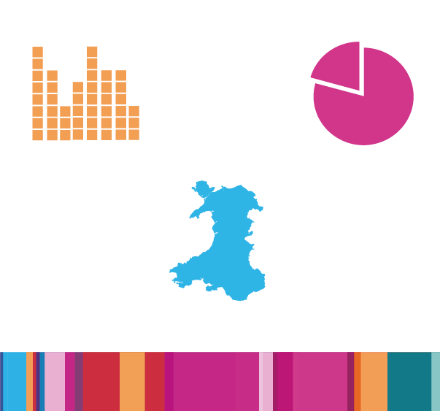

Careers Wales LMI Bulletin:

February 2025

Issue 17: Published February 2025

Date of next issue: June 2025

## Content

1. Content 2

2. Headlines for Wales in this edition 3

3. Job Posting Trends in Wales 4

4. Occupation Recruitment Trends 5

5. Redundancies 8

6. Employment, Unemployment and Economic Inactivity 9

7. Youth Unemployment and Young People Not in Education, Employment or Training (NEET) 13

8. The Regional Skills Partnerships 14

9. Feature: AI Jobs and Skills in Wales 15

10. Support, information and statistics 15

## Headlines for Wales in this edition

Headline data for Wales in this edition with decorative infographic showing 
1,356,000 people are in employment
Employment Rate decreased to 70.0%
85,000 people are unemployed 
Unemployment Rate increased to 5.9% 
Monthly Online Job Postings increased to 39,124 in September
20.8.% (364,000 people) aged 16-64 were economically inactive
70,788 economically inactive people said they want a job  
NEET aged 16-18 is 4,900 
NEET aged 19-24 is 30,800


## Job Posting Trends in Wales

NOTE: Monthly fluctuations in online job postings continue to provide us with a crude but responsive indication of the job market in Wales. The absolute numbers should be used with caution as they provide only a snapshot of the total recruitment picture.

### Recruitment trends in Wales

Bar Chart 1 (below) illustrates, monthly online job postings in Wales have been fluctuating slightly since their highest level in the last 12 months seen in March 2024, with an average of ~42,549 monthly postings over the last year.

This follows a similar pattern to job postings data for the UK, suggesting that the trends in Wales reflect what is happening across the UK.

Bar Chart 1: Monthly online job postings in Wales from February 2024 – January 2025

Source: LightcastTM Job Posting Analytics, February 2025 [Appendix 1: Accompanying Table of Data](https://publicfiles.careerswales.gov.wales/partners/lmi_bulletin_february_25_appendices.docx)

Posting Intensity is the total number of job postings for each unique job vacancy. The average intensity of 2:1 for January 2025 means that each new job posted in January was being advertised in 2 different media. A specific occupation with a posting intensity higher than the average of 2:1 for the month of January would suggest that employers are putting more effort into filling that vacancy.

## Occupation Recruitment Trends

NOTE: This data includes occupations greater than 100 job adverts posted between October 2024 and January 2025. Jobs with fewer than 100 adverts are removed to reflect a more accurate trend overall.

### Top 20 occupations advertised in the period October 2024 to January 2025

Bar Chart 2 below shows that Care Workers and Home Carers continue to be the top occupation with the highest total number of online job postings. Job postings for Care Workers and Home Carers in this reporting period was 3,738.

The highest posting intensity from the top 20 occupations advertised is for Secondary Education Teaching Professionals with an average at 5:1 (whilst national average was 2:1), which suggests these vacancies are hard to fill.

The top eight occupations in Wales with the most online job postings remain unchanged from the previous Bulletin.

Bar Chart 2: Top 20 occupations advertised in the period October 2024 to January 2025 in Wales

Source: LightcastTM Job Posting Analytics, February 2025 [Appendix 2: Accompanying Table of Data](https://publicfiles.careerswales.gov.wales/partners/lmi_bulletin_february_25_appendices.docx)

### Occupations with increasing demand in the period October 2024 to January 2025

Bar Chart 3 below shows the highest % increase in demand for this reporting period is for Delivery Drivers and Couriers at 68%. In numerical terms, this represents 217 job postings over 4 months across Wales, indicating a potential short-term shortage of workers or skills in this area. A more noteworthy increase in numerical terms is an increase of ~370 to 2,808 job postings (or 15%), in job postings for Teaching Assistants, suggesting hard to fill vacancies.

Increases in demand should be used with caution. The increases and decreases in demand across the 4 month period cannot be considered as a trend due to the short duration; it is a snapshot of that period and may reflect seasonal and regional or sector trends. It should also be noted that a high percentage change does not necessarily mean the highest number of vacancies.

Bar Chart 3: Top 20 occupations with the greatest % increase in Unique Job Postings advertised in the period October 2024 to January 2025 in Wales

Source: LightcastTM Job Posting Analytics, February 2025 [Appendix 3: Accompanying Table of Data](https://publicfiles.careerswales.gov.wales/partners/lmi_bulletin_february_25_appendices.docx)

### Occupations with decreasing demand in the period October 2024 to January 2025

Bar Chart 4 below shows the occupations with the highest % decrease in job postings from October 2024 to January 2025. Similar caution should be used to interpret the occupations with decreasing demand as this represents a short-term snapshot of 4 months and a high % can often represent very low numbers.

The occupations with the largest percentage decreases in job postings for this period compared to the previous one include:

* Gardeners and Landscape Gardeners (-44%, ~134 decrease in job postings)
* Bar Staff (-35%, ~254 decrease in job postings)
* Housekeepers and Related Occupations (-34%, ~146 decrease in job postings)

LightcastTM data shows that job postings for these three roles have consistently decreased between October 2024 and January 2025 over the past three years, compared to the previous four-month period. This trend suggests a possible link to seasonal work and reduced demand during that period.

A more significant numerical decrease is in Chefs job postings, which decreased by ~302 to 866 (a 26% decline compared to the previous period). Similarly, this could also be linked to seasonal work reducing after the Christmas period.

Bar Chart 4: Top 20 occupations with the greatest % decrease in Unique Job Postings advertised in the period October 2024 to January 2025 in Wales

Source: LightcastTM Job Posting Analytics, February 2025 [Appendix 4: Accompanying Table of Data](https://publicfiles.careerswales.gov.wales/partners/lmi_bulletin_february_25_appendices.docx)

## Redundancies

* Redundancy figures for Wales are based on a small sample size and are therefore volatile.
* Gaps in data have been occurring in the Wales statistical releases since April 2022.
* All redundancies relating to fewer than 3 businesses are suppressed by the ONS. This has resulted in less precise estimates and gaps in data for Wales.
* Redundancy trends for Wales reported in previous LMI Bulletins are available in [Appendix 5: Accompanying Table of Data](https://publicfiles.careerswales.gov.wales/partners/lmi_bulletin_february_25_appendices.docx)
* The latest ONS release on redundancies for Wales did not have any data updated for Wales.
* The full UK breakdown can be viewed in the [ONS, January 2025](https://www.ons.gov.uk/employmentandlabourmarket/peoplenotinwork/redundancies/datasets/redundanciesbyindustryagesexandreemploymentratesred02) release.

## Employment, Unemployment and Economic Inactivity

### Employment in Wales and the UK, aged 16-64

Graph 5 (below) illustrates the latest employment trends in Wales and the UK from June 2022 to November 2024 for people aged 16 to 64.

The employment rate in Wales showed an initial increase from June 2022 to June 2023, peaking at 72.9% (1,396,000 people). It has since declined to 70.0% in the latest data for November 2024, a reduction of 40,000 people to 1,356,000 people aged 16-64 in employment in Wales.

The UK rate has remained relatively stable from June 2022 to November 2024, where the latest data shows employment rate at 74.8% in November 2024 (32,227,000 people).

Wales' employment rates rose faster than the UK's until August 2023. After that, the trend reversed. Wales' rates fell, while the UK's remained stable with minor fluctuations.

Graph 5: Comparison of Employment in Wales and the UK, aged 16-64

Source: [Welsh Government, November 2024](https://statswales.gov.wales/Catalogue/Business-Economy-and-Labour-Market/People-and-Work/Labour-Market-Summary/labourmarketsummary-by-measure-age-ukcountry-quarter) [Appendix 6: Accompanying Table of Data](https://publicfiles.careerswales.gov.wales/partners/lmi_bulletin_february_25_appendices.docx)

### Unemployment in Wales and the UK, aged 16-64

Graph 6 (below) illustrates the latest unemployment trends in Wales and the UK from June 2022 to November 2024 for people aged 16 to 64.

Unemployment rate changes in Wales should be considered alongside longer-term trends due to the volatility of the series and small sample sizes. Wales shows more fluctuation over time, while the UK remains steadier.

The latest data for Wales for September to November 2024, shows that 5.9% (85,000 people) people aged 16 to 64 were unemployed. The timeline shows an increasing trend in Wales since June 2022 when both Wales and the UK rate was 3.7%.

Similarly, the UK rate has also increased, albeit at a slower rate, reaching 4.5% in the latest data for November 2024 (1,529,000 people), up from 3.7% (1,203,000 people) in June 2022.

Graph 6: Comparison of the Unemployment in Wales and the UK

Source: [Welsh Government, November 2024](https://statswales.gov.wales/Catalogue/Business-Economy-and-Labour-Market/People-and-Work/Labour-Market-Summary/labourmarketsummary-by-measure-age-ukcountry-quarter) [Appendix 6: Accompanying Table of Data](https://publicfiles.careerswales.gov.wales/partners/lmi_bulletin_february_25_appendices.docx)

### Economic Inactivity in Wales, aged 16-64

Economically Inactive defines people who are not in employment, not seeking work within the last 4 weeks and/or are unable to start work within the next 2 weeks.

The economic inactivity rate remains high in Wales and historically higher than the UK average. Since September 2019, the economic inactivity rate in Wales has increased, and remains more volatile than the UK.

Economic Inactivity rate changes in Wales should be considered alongside longer-term trends where possible due to the volatility of the series and small sample sizes. However, overall, the Wales and UK trends show similar movements.

The latest update available is for September 2024 and reports that 364,500 people (excluding students) aged 16-64 in Wales were economically inactive, a slight increase in number from September 2023, less than 1%.

This is a significant number of people and potential labour force, who are not contributing to the Welsh economy. Across the UK, economic inactivity remains a challenge to get people back into the labour market, with most people in this group reporting long term sickness as the reason.

Graph 7 (below) shows a comparison of the annual economic inactivity rates in Wales with the UK over the last 6 years, **excluding students**. The rate on 30 September 2024 for Wales was 20.8%, compared with 17.7% for the UK. The economic inactivity trend is increasing in Wales and across the UK.

**Graph 7:** Comparison of Economic Inactivity in Wales and the UK aged 16-64, excluding students

Source: [Welsh Government, September 2024](https://statswales.gov.wales/Catalogue/Business-Economy-and-Labour-Market/People-and-Work/Economic-Inactivity/economicinactivityratesexcludingstudents-by-welshlocalarea-year) [Appendix 7: Accompanying Table of Data](https://publicfiles.careerswales.gov.wales/partners/lmi_bulletin_february_25_appendices.docx)

Research has shown that economic inactivity continues to be the biggest social and economic challenge in the labour market. The Economically Inactive population of Wales can be reviewed in terms of the reasons for economic inactivity.

The latest data available for September 2024, and historic trends, show that the main reason why people are economically inactive in Wales (and the UK) is due to long-term sickness. The latest update reports that this number is 162,285 people in Wales (33.8%).

This data source also highlights that 14.7%, or just over 70,000 economically inactive people, **do want a job**.

**Pie Chart 8:** Economic Inactivity in Wales by Reason, October 2023 to September 2024

Source: [ONS, February 2025](https://www.ons.gov.uk/employmentandlabourmarket/peopleinwork/employmentandemployeetypes/datasets/headlinelabourforcesurveyindicatorsforwaleshi10) [Appendix 8: Accompanying Table of Data](https://publicfiles.careerswales.gov.wales/partners/lmi_bulletin_february_25_appendices.docx)

## Youth Unemployment and Young People Not in Education, Employment or Training (NEET)

Graph 9 (below) illustrates a comparison of 16 to 18-year-olds reported as NEET (Not in Education, Employment or Training) with 19–24-year-olds reported as NEET from the Annual Population Survey (APS) statistics.

The latest data shows that the NEET rate for 16 to 18-year-olds in Wales has declined since September 2022 from 9.3% to the latest rate in September 2024 of 4.9% (~4,900 individuals).

Historically, in Wales and the UK, the 19 to 24-year-old NEET group continues to be at a much higher rate when compared to the 16 to 18 age group. However, the trend for this group has seen a decrease since September 2023 from 16.4% to 13.2%, currently ~30,800 people in September 2024.

This is a significant number of people, and potential labour force, who are not contributing to the Welsh economy. Young people who are NEET are also contributing to the Economic Inactive population.

Graph 9: Comparison of Young People Not in Education, Employment or Training (NEET) in the   
16-18 and 19-24 age groups

Source: [Welsh Government, September 2024](https://www.gov.wales/young-people-not-education-employment-or-training-neet-october-2023-september-2024) [Appendix 9: Accompanying Table of Data](https://publicfiles.careerswales.gov.wales/partners/lmi_bulletin_february_25_appendices.docx)

Note: The NEET statistics are based on a limited sample size and are categorised as being of low quality.

## The Regional Skills Partnerships

### Find out about skills needed by employers across the regions of Wales

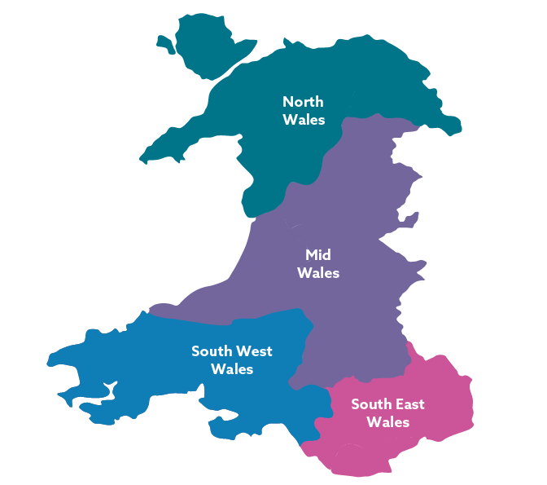

[North Wales Regional Skills Partnership](https://www.rspnorth.wales/)

[Mid Wales Regional Skills Partnership](https://growingmidwales.co.uk/)

[South West Wales Regional Learning and Skills Partnership](https://www.rlp.org.uk/eng)

[Cardiff Capital Regional Skills Partnership](https://www.ccrsp.co.uk/eng/data-observatory)

Find out more information, links and data relating to industries, employment and skills across the 4 regions of Wales in [Future Jobs Wales](https://careerswales.gov.wales/future-jobs-wales)

**[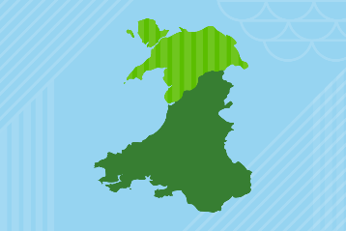](https://careerswales.gov.wales/future-jobs-wales/jobs-in-north-wales)** **[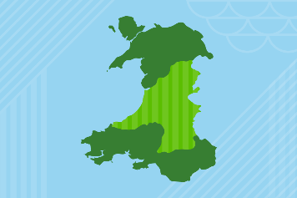](https://careerswales.gov.wales/future-jobs-wales/jobs-in-mid-wales)**

North Wales Mid Wales

**[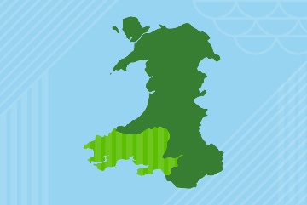](https://careerswales.gov.wales/future-jobs-wales/jobs-in-south-west-wales)** **[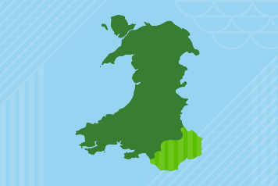](https://careerswales.gov.wales/future-jobs-wales/jobs-in-south-east-wales)**

South West Wales South East Wales

## Feature: The AI Economy in Wales

[](https://careerswales.gov.wales/sites/default/files/images/the-ai-economy-in-wales-february-2025.pdf)

* [The AI Economy in Wales](https://careerswales.gov.wales/sites/default/files/images/the-ai-economy-in-wales-february-2025.pdf)

## Support, information and statistics

**Working Wales and Careers Wales** offer information and help with

* [Young Person’s Guarantee](https://workingwales.gov.wales/how-we-can-help/young-persons-guarantee)
* [ReAct Plus](https://workingwales.gov.wales/how-we-can-help/react-plus)
* [Personal Learning Accounts](https://careerswales.gov.wales/courses-and-training/funding-your-studies/personal-learning-accounts)
* [Redundancy](https://careerswales.gov.wales/plan-your-career/options-after-redundancy)
* [Apprenticeships](https://careerswales.gov.wales/apprenticeship-search)
* [Course Search](https://careerswales.gov.wales/course-search)
* [Getting A Job](https://careerswales.gov.wales/getting-a-job)
* [Job Bulletin](https://careerswales.gov.wales/getting-a-job/job-bulletin)
* [Support Finder](https://careerswales.gov.wales/support-finder)

The **DWP** offer services, including

* [Find A Job](https://findajob.dwp.gov.uk/)
* [Job Help](https://jobhelp.campaign.gov.uk/)

**Business Wales** offer tailored support for businesses, including

* [Skills Gateway for Business](https://businesswales.gov.wales/skillsgateway/)

**Labour Market Statistics**

* [Future Jobs Wales](https://careerswales.gov.wales/future-jobs-wales)
* [Welsh Government Labour Market Overview: September 2024](https://www.gov.wales/labour-market-overview-september-2024)
* [Labour market overview, UK - Office for National Statistics September 2024](https://www.ons.gov.uk/employmentandlabourmarket/peopleinwork/employmentandemployeetypes/bulletins/uklabourmarket/september2024)
* [Labour Market Statistics, September 2024 - Institute for Employment Studies](https://www.employment-studies.co.uk/resource/labour-market-statistics-september-2024)
* [Welsh economy in numbers: interactive dashboard | GOV.WALES](https://www.gov.wales/welsh-economy-numbers-interactive-dashboard)

We welcome questions and feedback on the data and key messages included in LMI Bulletins. Please send to [information@careerswales.gov.wales](mailto:information@careerswales.gov.wales)

[Sign-up](https://forms.office.com/pages/responsepage.aspx?id=0VDI528znE-0BD9pkcJLs61qmyO82lhJiG3u4a3koaVURUc3UENGWlZIUklNSUpZRzBKOE5aQk44SiQlQCN0PWcu) to receive the LMI Bulletin from Careers Wales